Max-Planck-Institut für Physik
WERNER-HEISENBERG-INSTITUT

Munich, January 2001

Alternative Spine Designs

Hans-Günther Moser

Abstract

The increase of the spine width (=width of the TPG bar) from 12 mm to 23 mm results in a significant cost increase of the spine. In order to compensate for this alternative spine designs have been proposed which have cost saving potential. Clearly these alternatives should have comparable thermal and mechanical properties, in addition to cost saving. Ignoring combinations and material variations there exist six basic variations. They will be discussed and costs and performance will be compared.
This paper is intended to compile information and prepare discussions and finally decisions in the spine working team.
1. Design variations

Sketches of the designs can be found in figure (1). Clearly these rough sketches do not show all the details.

Figure 1: Sketches with different spine variations. See text for explanations

In short the variations can be characterized as follows:

1) Present baseline: Profiled AlN (0.5 mm and 0.225 mm thickness) crossbars glued on profiled TPG.

Advantages: Very stable AlN wings.

Weakness: AlN profiling becomes expensive for 23 mm (machining time, reduced yield).
Limited options for AlN replacement (only middle wing).
TPG breaks easily at profiled edges, especially at middle wing. (For 12 mm TPG, with 23 mm there should not be a problem).

2) NIITAP proposal: AlN crossbars are replaced by 3(2) small pieces: 0.225 mm plates at cooling contacts, and profiled wings (step). The TPG profiling is as in 1) which can be machined easily.

Advantages: Breaking the AlN into small pieces makes the AlN sets cheaper. The quote is 50 US$ for 23 mm instead of 66 US$ for the present 12mm baseline, which will become even more expensive for 23 mm.
Possibility to replace all wings by other materials.

Weakness: TPG weak at profiled edges, especially at middle wing (for 12 mm TPG, with 23 mm
there should not be a problem).
More complicated assembly.

3) Butt joints: Wings are attached to the TPG using simple butt joints and 0.225 AlN plates are used at the cooling contacts

Advantages: Cheapest solution. AlN or replacement does not need to be profiled.
TPG is not profiled in the middle, hence it is mechanically stronger.
Thermal advantage due to non-profiling of TPG in the middle.
AlN at cooling contacts can be reduced leaving more TPG, which improves the thermal properties.
ALN wings can be replaced by other materials

Weakness: Butt joints are very fragile.
AlN plates at cooling contact are attached only to the TPG, a solution which may be mechanically weaker than alternatives where the AlN is also glued to the detectors (However, the ALN can be made larger so that it extends under the silicon).

4) Geneva I: The AlN wings have step like profiles, similar profiles are machined in the TPG to achieve larger gluing areas. 0.225 mm AlN plates are used at the cooling contacts.

Advantages: Cheaper, costs for AlN or replacement should be like for 2).
TPG is not profiled in the middle: hence it is mechanically stronger.
Thermal advantage due to non-profiling of TPG in the middle.
AlN at cooling contacts can be reduced leaving more TPG, which improves the thermal properties.
ALN wings can be replaced by other materials

Weakness: Despite the larger glue area the joints are as fragile as simple butt joints (see below).
It is difficult to machine the TPG (it works manually for a prototype, but it is not recommended for series production).
AlN plates at cooling contact are attached only to the TPG, a solution which may be mechanically weaker than alternatives where the AlN is also glued to the detectors (However, the ALN can be made larger so that it extends under the silicon).

5) Geneva II: The butt joint are inserted in cut-outs of the TPG for wings at low and middle wing, a profiled (step) wing is glued on extended AlN cooling contact plate at upper wing. The original drawing has a complicated geometry for the TPG at the lower contact, which is difficult to machine, see figure 6). However, this can be simplified.

Advantages: Costs like for 2) or lower.
The "inserted butt joint" is surprisingly rigid (see below).
TPG is not profiled in the middle: hence it is mechanically stronger.
Thermal advantage due to non-profiling of TPG in the middle.
AlN at cooling contacts can be reduced leaving more TPG which improves the thermal properties.
ALN wings can be replaced by other materials

Weakness: AlN plates at cooling contact are attached only to the TPG, a solution which may be mechanically weaker than alternatives where the AlN is also glued to the detectors (However, the ALN can be made larger so that it extends under the silicon).

6) Geneva II (mod): Like 5) with wings at lower cooling contact made like the upper wing in 5).

Advantages: Costs like for 2) or lower.
The "inserted butt joint" is surprisingly rigid (see below).
TPG is not profiled in the middle: hence it is mechanically stronger.
Thermal advantage due to non-profiling of TPG in the middle.
AlN at cooling contacts can be reduced leaving more TPG which improves the thermal properties.
ALN wings can be replaced by other materials

Weakness: ???

Clearly combinations of features from different variations are possible: e.g. use 6) for the upper and lower wings and 2) for the middle wing.

4. Material variations

There are probably good reasons to keep AlN for the cooling contacts (see section 4). In all designs except 1) these are small plates of uniform thickness, which should not be very expensive (see section 3).

For the wings more variations are possible:

AlN of lower conductivity (120 W/mK, 160 W/mK): This variation is cheaper and easier (=cheaper) to machine. It still has a fairly high thermal conductivity and a good CTE match to silicon.

Al₂O₃: the raw material is certainly cheaper than AlN. However, machining is not much different from AlN, it has a worse CTE mismatch, and rather low thermal conductivity.

Quartz/glasses: Probably like Al₂O₃, the thermal conductivity is even worse.

FR4, glass fibre reinforced peek or similar materials: These materials are probably very cheap and easy to machine. The thermal conductivity is bad, CTE mismatch rather large.

Others ???

Remark: Conductive materials should be avoided for various reasons: HV insulation, noise….

Table 1): Evaluation of design variations. Clearly the criteria do not have equal weight and the evaluation is not unique. Solutions which have no big disadvantages are 2), 5), and 6)
Design | 1) Baseline | 2) NIITAP | 3) Butt joints | 4) Geneva I | 5) Geneva II | 6) 5, mod
Costs (+: cheaper) | -- | + | +(+) | + | + | +
Fragility of wings | + | + | -- | -- | 0(+) | 0(+)
TPG machining | 0 | 0 | 0 | -- | 0 | 0
AlN machining | -- | 0 | + | 0 | 0(+) | 0(+)
AlN replacement | -- | + | + | + | + | +
Fragility of TPG | 0 | 0 | + | + | + | +
Stability contact | + | 0 | --(0) | --(0) | --(0) | 0
Thermal properties | 0 | 0 | + | + | + | 0

3. AlN price

The price for 225 μm AlN plates of 114 x 114 mm² from Ceramtec is 125 DM (>20 plates). The minimum amount of AlN needed (assuming version 6) for the cooling point contacts is:

The main contact fits within 27 mm x 17.43 mm. Assuming the laser cut needs 0.1 mm spacing between pieces (achievable) and only 110 x 110 mm² of the available area is used (edges are of poor quality) at least 21 pieces can be cut out of a plate:

5.95 DM/piece or < 3 US$

The far end contact has an area of 10 x 27 mm and 39 pieces could be made out of a plate:

3.2 DM/piece or 1.5 US$

Similarly the set price for the AlN wings should be (based on 95 DM for a 0.5 mm AlN plate)

Lower wings: 5.6 DM/piece
Centre wings: 6.9 DM/piece
Upper wings: 5.0 DM/piece
---------------------
Set 17.5 DM/set

These are prices for material only. Costs for laser cutting (and eventually profiling) have to be added.

4. FEA simulations of AlN replacements

In a configuration similar to 2) [the results depend only very marginal on the actual design chosen] the AlN wings were replaced by Al₂O₃ (Ck=20 W/mK):

1) Lower wing only (near 2nd cooling block)
2) Centre wing only
3) Upper wing only (near main cooling block)

The cooling block contact inserts remain AlN

4) All AlN parts are replaced by Al₂O₃ (including the inserts)

In all cases the coolant temperature is –17 C. Convection is not simulated. The runaway curves are shown in figure 2) and the results are summarized in the table below:

Table 2): results of FEA simulations of AlN replacement options:

Option | ΔT at Q0=240 W/m2 (K) | Runaway (W/m²)
1) All AlN | - | 380
2) Lower wing Al₂O₃ | 0 | 380
3) Centre wing Al₂O₃ | 0 | 380
4) Upper wing Al₂O₃ | 0.5 | 380
5) All Al₂O₃ | 1.0 | 330

So, in 1) and 2) changes of thermal performance are negligible and cannot be resolved by the FEA.

Version 3) shows a slight deterioration of the performance. For Q0=240 W/m² the maximum silicon-temperature increases by ca. 0.5 C. The runaway point does not change within the resolution of the FEA (10 W/m²)

Version 4) shows a stronger deterioration of the performance. The maximum silicon-temperature at Q0=240 W/m² increases by 1 C (compared to version 3) and the runaway occurs at 330 W/m² instead of 380 W/m²

The effect of replacing the AlN inserts at the cooling contacts by Al₂O₃ corresponds to a decrease of the TPG width from 23 mm to 16.5 mm.

Figure 2): FEA simulations of various options for replacement of AlN. Upper plot: maximal silicon temperature as function of the radiation damage induced power density (normalized to 0 C). Lower plot: Coolant temperature as function of power density at runaway.

5. Tests of joining techniques

In order to test the stability of different AlN/TPG joining techniques four different joints were made and tested by putting weights on the end of the wings (see figure 3):

Table 3): Tests of TPG/AlN joints:

Type | Weight to break
1) Simple butt joint | 30 g
2) Stepped joint | 28 g
3) Inserted butt joint | 66 g
4) Baseline profile | ---- (TPG disrupted before..)

Surprisingly the stepped joint is not stronger than the simple butt joint. The reason is TPG delamination under the glue area (of course the joint becomes stronger if the area increases. In out test the overlap was 2.2 mm). The broken joints are shown in figure 4).

The inserted butt joint is surprisingly rigid. The weight applied is certainly more than needed. In our case the cutout for the insert was 2 mm. The only problem we could see is glue spilling out of the joint and contaminating the area around the joint. Probably some more work is needed to find the optimal gluing procedure. Figure 5) demonstrates how this joint supports quite an impressive weight.

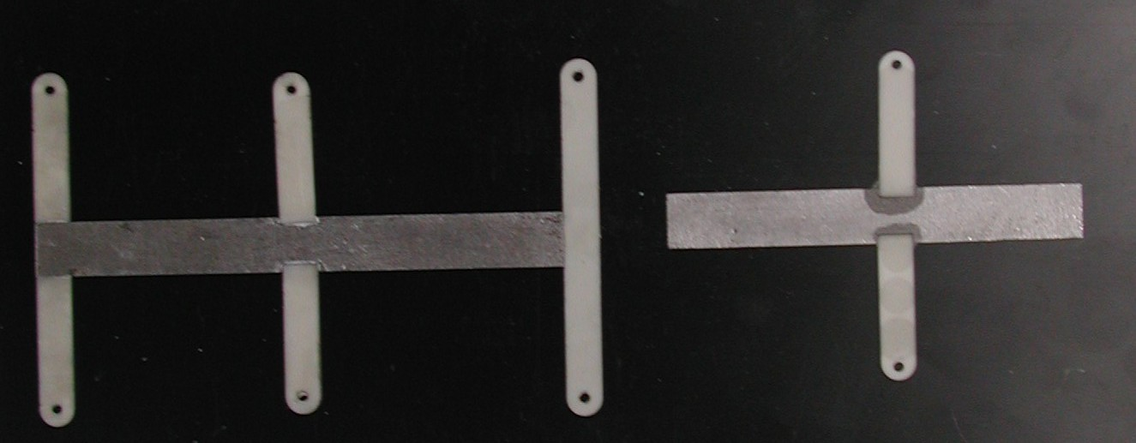

Figure 3): TPG/AlN joints. From left to right: Simple butt joint; joint with step-like profiling of TPG and AlN; fully profiled baseline joint; butt joint in TPG cut-out (the TPG bar is 12mm wide)

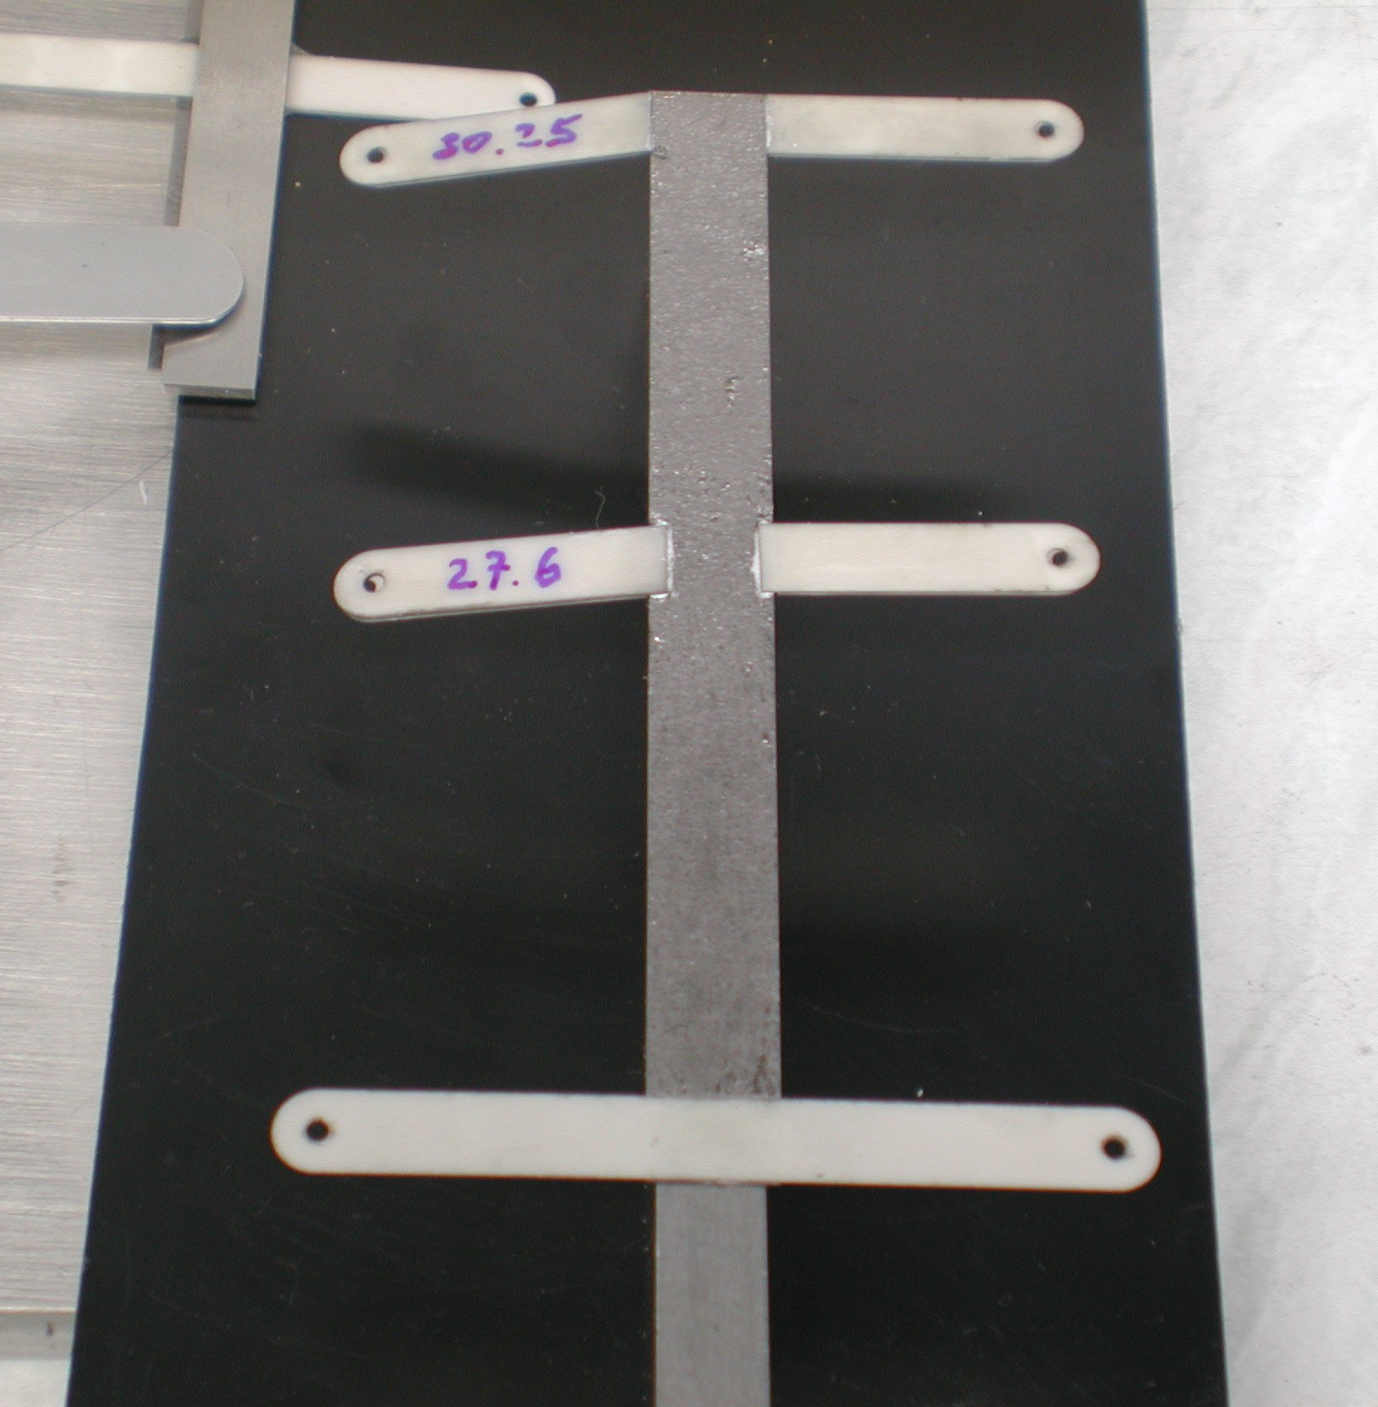

Figure 4) Butt joint (top) and step-like profiled joint (middle) after load test. Both joints broke with a weight of 30.3 g or 27.6 respectively. The baseline joint did not break; finally it delaminated from the TPG.
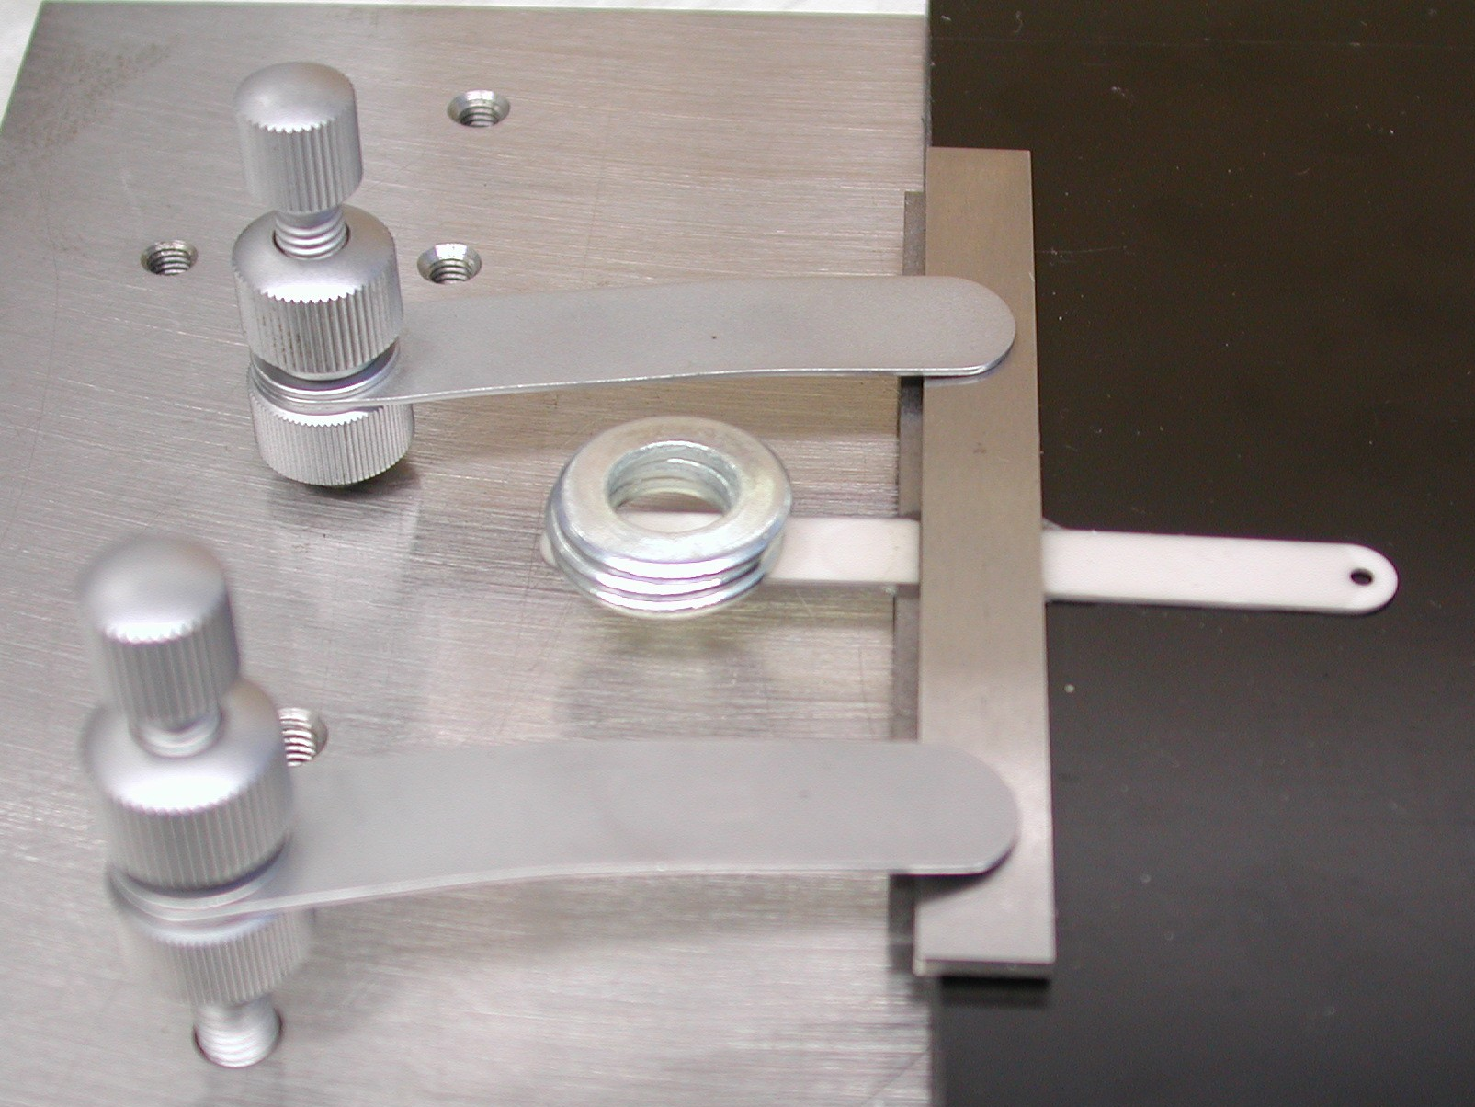

Figure 5): Inserted butt joint with load applied. It broke finally under a load of 66 g.

6. Conclusions

Increasing the TPG width from 12 mm to 23 mm results in a substantial price increase of the spine. This can at least partially be compensated by optimising the spine design, especially the shape and material of the stiffening and support wings. Several alternatives are proposed and it can be shown that some of them offer price advantages keeping (or even improving) the properties of the baseline design. A large part of the price reduction comes from new joining techniques, which avoid large area profiling of the AlN (and TPG). It could be demonstrated that at least one of these techniques offers satisfactory stability. With these design changes the price can (almost) be brought back to the original 12 mm baseline price (see tables 4 to 6).
Further reduction of costs may be possible by replacing (parts) of the AlN pieces by other, cheaper materials. Using FEA it can be demonstrated that replacing the lower (far) and middle wings by such materials does not lead to a measurable change of thermal performance, despite the inferior thermal conductivity of those materials. In case of the upper (main) wing a slight (perhaps tolerable) deterioration of the thermal performance is observed. The replacement of the AlN cooling block contact pieces, however, is not recommended.

Table 4): Prices of old baseline with 12mm spine width:

 | Outer | Middle | Middle 6 | inner
width/mm | 12 | 12 | 23 | 23
TPG | 40 USD | 40 USD | 48 USD | 48 USD
AlN | 66 USD | 65 USD | 48 USD | 48 USD
Net price | 106 USD | 105 USD | 96 USD | 96 USD
VAT | 13 USD | 13 USD | 12 USD | 12 USD
Packing, transport | 14 USD | 14 USD | 14 USD | 14 USD
Total/spine | 133 USD | 132 USD | 122 USD | 122 USD
Pieces | 1170 | 700 | 100 | 500
Total | 155.282 USD | 92.120 USD | 12.152 USD | 60.760 USD
All Spines | 320.314 USD

Table 5): Prices of baseline with 23mm spine width:

 | Outer | Middle | Middle 6 | inner
width/mm | 23 | 23 | 23 | 23
TPG | 65 USD | 65 USD | 48 USD | 48 USD
AlN | 80 USD | 81 USD | 48 USD | 48 USD
Net price | 145 USD | 146 USD | 96 USD | 96 USD
VAT | 17 USD | 18 USD | 12 USD | 12 USD
Packing, transport | 14 USD | 14 USD | 14 USD | 14 USD
Total/spine | 176 USD | 178 USD | 122 USD | 122 USD
Pieces | 1170 | 700 | 100 | 500
Total | 206.388 USD | 124.264 USD | 12.152 USD | 60.760 USD
All Spines | 403.564 USD

Table 6): Prices of IHEP proposal (variation 2)) with 23mm spine width:

 | Outer | Middle | Middle 6 | inner
width/mm | 23 | 23 | 23 | 23
TPG | 65 USD | 65 USD | 48 USD | 48 USD
AlN | 50 USD | 50 USD | 36 USD | 36 USD
Net price | 115 USD | 115 USD | 84 USD | 84 USD
VAT | 14 USD | 14 USD | 10 USD | 10 USD
Packing, transport | 14 USD | 14 USD | 14 USD | 14 USD
Total/spine | 142 USD | 142 USD | 108 USD | 108 USD
Pieces | 1170 | 700 | 100 | 500
Total | 166.464 USD | 99.594 USD | 10.849 USD | 54.244 USD
All Spines | 331.151 USD

Figure 6): Drawing of the Geneva II design (by C. Hirt)

